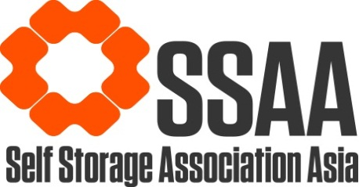

TERMS & CONDITIONS OF USE
In accepting and using any and all forms of agreements (“Agreements”) provided to you by the Self Storage Association Asia (“SSAA”), and/or its affiliates (“Affiliates”), you accept and agree to be bound by the following terms and conditions (“Conditions”):

- You shall be responsible for ensuring that you are in compliance with any and all laws, regulations and rules applicable to you in relation to your use of the Agreements.

- The information contained herein in this letter and the Agreements are not provided for any specific purpose, and do not constitute legal, regulatory, financial, commercial or other professional advice, and should not be relied upon or treated as a substitute for specific advice (including legal advice) relevant to particular circumstances. For avoidance of doubt, SSAA and their Affiliates accept no responsibility and make no warranties (expressed or implied) as to the accuracy, quality or fitness for any particular purpose of the contents of this letter and the Agreements. Accordingly, you are encouraged to seek independent legal and/or other relevant advice on all matters, if necessary including with respect to the content, suitability and enforceability of the Agreements in the relevant jurisdiction(s).

- You acknowledge that any and all intellectual property rights associated with this letter and the Agreements (including without limitation any trade secrets and copyright) belong to SSAA and/or their Affiliates. Accordingly, in receiving and accepting this letter and the Agreements, you undertake not to without the prior written consent of SSAA and/or its Affiliates republish, reproduce, distribute or transmit to any other any other person or post on any public website, domain, portal or whatsoever this letter and/or the Agreements, and/or their content.

- To the maximum extent permitted by applicable law, SSAA and Affiliates do not accept and exclude any and all liability under any circumstances for any loss or damage of any kind including, without limitation, any direct, special, indirect or consequential loss or damage, arising out of or in connection with the use of the Agreements and/or this letter or from any reliance that may be placed by any person on any information of whatever nature which may be made available to that person as a result of using the Agreements and/or this letter.

