CUSTOMER (DANGEROUS GOODS) DECLARATION FORM | Company Logo

Storage Address:  Customer Name and Address: | Date:  Storage Unit Number:
Customer Notice
According to Dangerous Goods Ordinance Section 6:
‘Except under and in accordance with a license granted under this Ordinance, no person shall manufacture, store, convey or use any dangerous goods.’
Category 1: Explosives and blasting agents. Category 2: Compressed gases. Category 3: Corrosive substances. Category 4: Poisonous substances. Category 5: Substances giving off inflammable vapour. Category 6: Substances which become dangerous by interaction with water. Category 7: Strong supporters of combustion. Category 8: Readily combustible substances. Category 9: Substances liable to spontaneous combustion. Category 9A: Combustible goods. Category 10: Other dangerous substances including refrigerants
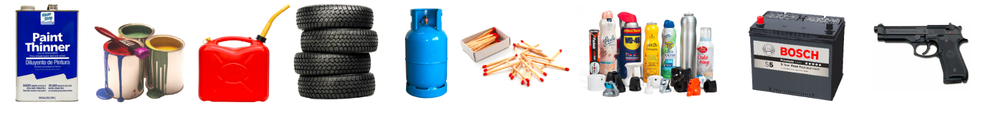
Our Company provides 24 hours CCTV surveillance to monitor the safe environment of the facility. Our staff will patrol the facility frequently and may inspect the storage cubicles to ensure no dangerous goods are stored in the facility, if any were found, our staff will demand the customer to remove the dangerous items from the facility. If customers ignore our demands, our company will terminate the contract with the customer in writing with immediate effect in other to maintain a safe environment of the facility.
Declaration for Illegal & Dangerous Goods:
 | Aerosols, Refrigerants, Gasoline, LPG |  | Toxic, Corrosive substance, oxidizing agent
 | Paint, Thinner |  | Illegal items such as narcotics and illicit cigarettes
 | Batteries |  | Copy watches, bags, and other such materials
 | Ammunition, dynamite and firearms |  | Other flammable items

Declaration for Ordinary Goods:
 | Clothing, Shoes |  | Furniture, such as sofas, chairs and tables
 | Bed sheets, Duvet, Mattresses |  | Electronics, such as TVs, heaters, stereo, etc
 | Books, photos |  | Other Items
*Please tick the box where it is appropriate.

I/ My company ________________ declare that no dangerous and/or illegal items as stated on this document will be stored in the facility. We fully understand any violations will result in legal, contractual or civil responsibilities and the facility reserves the right to terminate the contract, withhold the deposit and pursue any legal actions. Law enforcement actions may also be taken by the relevant government departments.

Our company will strictly enforce fire safety regulations, please comply with the policy

Signatures (and Company Chop):_______________________

